ADVERTISEMENT FOR BIDS

Sealed proposals will be received until 11:00am on Thursday, January 8, 2026, in the Appalachain State Univerersity Planning, Design and Construction large conference room at 2458 NC Highway 105, Boone, NC for the construction of Rivers Street Tunnel Steam Line Repairs and Structural Shoring project at which time and place bids will be opened and read aloud.
Complete plans and specifications for this project can be obtained from:
Dewberry Engineers Inc.
9300 Harris Corners Parkway, Suite 220
Charlotte, NC 28269-3797
(704) 509-9918
during normal office hours after December 15, 2025.

Plans and specifications are also available via email from Tony Miller, PE at admiller@dewberry.com.
No pre-bid meeting is scheduled for this advertisement.
Copies may be obtained from Dewberry Engineers Inc. upon deposit of one hundred dollars ($100) in cash or certified check. The full plan deposit will be returned to those bidders provided all documents are returned in good, usable condition within ten (10) days after the bid date.
The state reserves the unqualified right to reject any and all proposals.

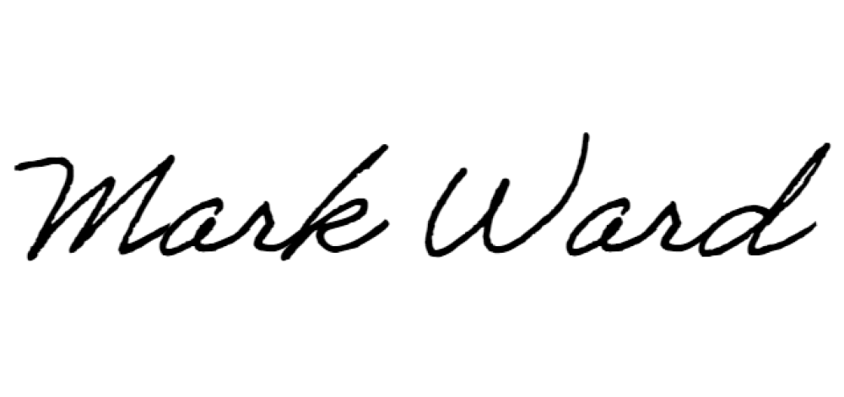
Signed: Mr. Mark Ward, PE

